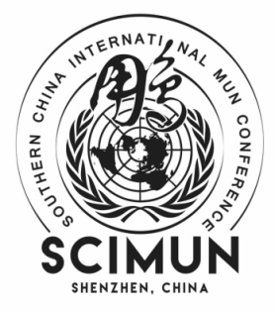
SCIMUN 2023
SCIMUN VI Participant Form and Country Assignments

Payment Details:
The payment per delegate is 450 RMB.
If the student wants to stay at a hotel during the conference days, it will be 1000 RMB.
Advisors will be charged separately. Advisors who don’t need to stay at a hotel for the three-day conference will be 250 RMB each. If the advisors will stay at a hotel, it will be an additional 1100 RMB each.

If you withdraw from the conference after January 8th, 2023, we will not refund unless its due to COVID restrictions or other serious causes.

Please fill out the following document as accurately as possible. The completed form is due to scimun2022@outlook.com by December 3rd, 2023. The earlier the submission, the more we will appreciate it. Thank you!

School Name:
Number of Delegates:

 | FULL NAME | GENDER | GRADE (6-12) | ASSIGNED COMMITTEE | COUNTRY

Advisor 1

Advisor 2

Delegate 1

Delegate 2

Delegate 3

Delegate 4

Delegate 5

Delegate 6

Delegate 7

Delegate 8

Delegate 9

Delegate 10

